* 1-D signal

x = input('Enter elements of arrays: ');

[r,c] = size(x);

W = zeros(c,c);

for j=0:c-1

for k=0:c-1

W(j+1,k+1) = exp((-1i\*2\*pi\*j\*k)/c);

end

end

W

ans = zeros(1,c);

ans = W\*x'

idft = (1/c)\*(W' \* ans)

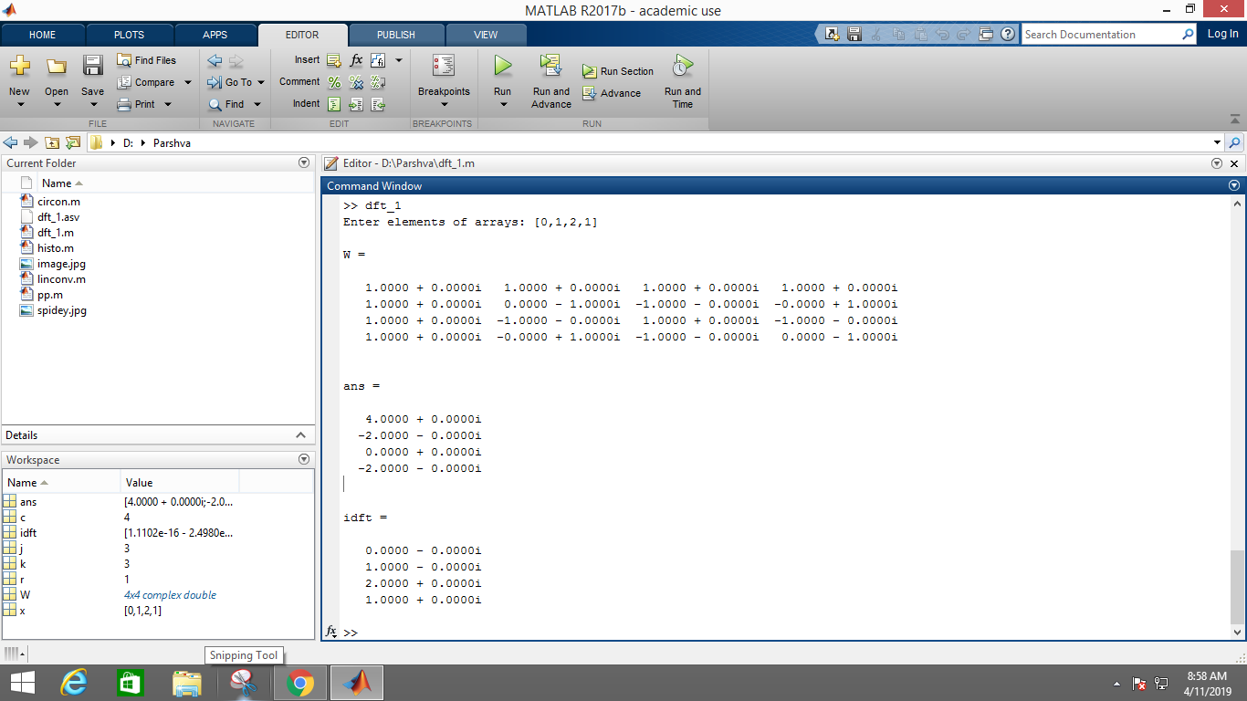

* 2-D signal

im = imread('spidey.jpg');

im = rgb2gray(im);

im = imresize(im,[128,128]);

subplot(2,2,1);

imshow(im);

title('Original image');

W = zeros(128,128);

for j=0:127

for k=0:127

W(j+1,k+1) = exp((-1i\*2\*pi\*j\*k)/128);

end

end

dft = W\*double(im)\*W';

subplot(2,2,2);

imshow(dft);

title('DFT of image');

idft = (1/(128\*128))\*(W' \* double(dft) \* W);

subplot(2,2,3);

imshow(idft,[]);

title('IDFT of image');

